Target article:
Toward Equity in Research on Intellectual and Developmental Disabilities
Sara T. Kover and Leonard Abbeduto

Word Counts:
Abstract: 60
Main Text: 1231
References: 142
Entire text: 1527

Commentary Title:
Moving the Needle Toward Equity: What NIH is Doing to Promote Diversity, Inclusion and Accessibility in Research on Intellectual and Developmental Disabilities

Tracy M. King¹ and Melissa A. Parisi¹
¹Eunice Kennedy Shriver National Institute of Child Health and Human Development
Bethesda, Maryland, USA
tracy.king@nih.gov
parisima@mail.nih.gov

Abstract
As a major funder of IDD research, NIH has a broad view of the profound impact of cultural and structural barriers on the characteristics of IDD study populations and the composition of the IDD research workforce. While long overdue, multiple efforts are currently underway across NIH aimed at addressing these barriers and increasing meaningful representation in biomedical and behavioral research.

Moving the Needle Toward Equity: What NIH is Doing to Promote Diversity, Inclusion and Accessibility in Research on Intellectual and Developmental Disabilities

We are deeply appreciative of Kover and Abbeduto’s comprehensive articulation of the many barriers to meaningfully inclusive research on intellectual and developmental disabilities (IDD), as well as their recommendations for advancing equity across all aspects of the IDD research enterprise. From our positions as major funders of IDD research, we at NIH have witnessed – and, admittedly, often perpetuated – the profound effects of cultural and structural barriers on the characteristics of IDD study populations and the composition of the IDD research workforce. While long overdue, multiple efforts are currently underway across NIH aimed at addressing these barriers and increasing meaningful representation in biomedical and behavioral research.
Many efforts to address health disparities and workforce diversity across NIH are being organized under the auspices of the NIH UNITE Initiative (https://www.nih.gov/ending-structural-racism/unite). UNITE is a wide-ranging effort with elements targeting the internal NIH workforce, the external biomedical and behavioral research workforce, and health disparities/minority health research. A number of individual NIH institutes have also created their own complementary initiatives; for example, at our institute, the Eunice Kennedy Shriver National Institute of Child Health and Human Development (NICHD), diversity, equity, inclusion and accessibility (DEIA) initiatives are being organized under the umbrella of the STRIVE initiative (STrategies to enRich Inclusion and achieVe Equity; https://www.nichd.nih.gov/about/org/strive). Like the NIH-wide UNITE effort, STRIVE has components addressing NICHD’s internal workforce, the broader scientific workforce relevant to NICHD’s mission, and health disparities research with a specific lens to NICHD’s priority populations, including individuals with IDD. In addition to these overarching DEIA initiatives, we highlight below several specific NIH efforts which directly address points raised by Kover and Abbeduto.
Plans for Enhancing Diverse Perspectives (PEDPs)
Recognition of disparities in the NIH-funded research workforce date back at least to 2011, when Ginther and colleagues (Ginther et al., 2011) brought attention to the significant disparities in R01 research award rates by race and ethnicity. A decade later, Plans for Enhancing Diverse Perspectives (PEDPs; https://braininitiative.nih.gov/about/plan-enhancing-diverse-perspectives-pedp) were introduced as a required component of funding opportunities published by the NIH BRAIN Initiative®, and have since been adopted by a growing number of NIH funding opportunities, including some, such as the Autism Centers of Excellence (ACE) Program (https://www.nichd.nih.gov/research/supported/ace) specific to IDD research.
Funding opportunities that include PEDPs require applicants to include elements that promote diverse perspectives in their research. Important distinguishing characteristics of PEDPs include the following:
- When included in a funding opportunity, the PEDP requirement applies to all applicants, regardless of scientific topic, discipline, or methods.
- PEDPs explicitly encourage applicants to engage with community-based partners to ensure alignment of research goals and activities with community values.
- Applicants must include timelines, milestones, and approaches to measuring progress toward their defined goals

Perhaps most importantly, PEDPs are part of scorable criteria during peer review and are used to inform funding decisions during programmatic reviews.
Addressing Individual and Systemic Biases in Peer Review
Peer review is a cornerstone of the process by which NIH selects applications for funding. However, there is increasing acknowledgement that individual and systemic biases in the NIH peer review system serve to maintain or even exacerbate disparities in funding for applicants from underrepresented or marginalized groups. In the words of Dr. Noni Byrnes, Director of the NIH Center for Scientific Review (CSR): “The systemic advantages of reputation, network and pedigree are deeply entrenched in the culture of the biomedical research enterprise, and rarely benefit [applicants from marginalized groups], who are less likely to be part of these networks.” (Byrnes, 2021)
CSR is currently pursuing a multi-pronged approach to reforming the NIH peer review process, including:
- Simplifying peer review criteria
- Piloting approaches to decouple the science from the investigator/environment during review, such as anonymizing the review process so investigator and institutional identities are not known by reviewers
- Diversifying and broadening the pool of reviewers
- Diversifying the scientific review officer (SRO) workforce
- Opening avenues for easier reporting of concerns regarding bias in peer review

Enhancing Disability Inclusion
In August 2021, the Advisory Committee to the NIH Director (ACD)’s Working Group on Diversity (WGD) established a Subgroup on Individuals with Disabilities (https://acd.od.nih.gov/working-groups/disabilitiessubgroup.html). It was originally charged with identifying strategies to support disabled persons in the biomedical research workforce; however, the Subgroup quickly found a need to broaden their scope to include health and health care disparities affecting disabled people, as well as increasing inclusion of disabled people in research studies.
In the report (ACD WGD Subgroup on Individuals with Disabilities, 2022) summarizing their findings and recommendations, Subgroup members noted several major barriers to their efforts, including:
- The lack of comprehensive and reliable disability data
- Varying definitions of disability, limiting the feasibility of direct comparisons among studies
Despite these barriers, the Subgroup’s final report includes a series of suggestions for the ACD’s consideration. These suggestions included:
- Removing the language of “reducing disability” from the NIH mission statement
- Formally designating people with disabilities as a health disparity population
- Collecting data on disability wherever demographic information is collected within NIH data systems
- Encouraging NIH institutes and centers to adopt community engagement requirements that maximize inclusion of people with disabilities in research
These suggestions were formally endorsed by the NIH ACD on December 9, 2022; NIH staff are now reviewing them in detail and considering how best to move forward with implementation. (Bernard, 2022)
Future Challenge: Addressing the full range of systemic barriers to research participation
Despite these multiple efforts across NIH, much work remains to address the systemic barriers that impede disabled individuals’ opportunities to fully participate in research. Consider Figure 1, which illustrates the multiple steps an individual might be required to navigate to participate in a diagnosis-specific biomedical research study.

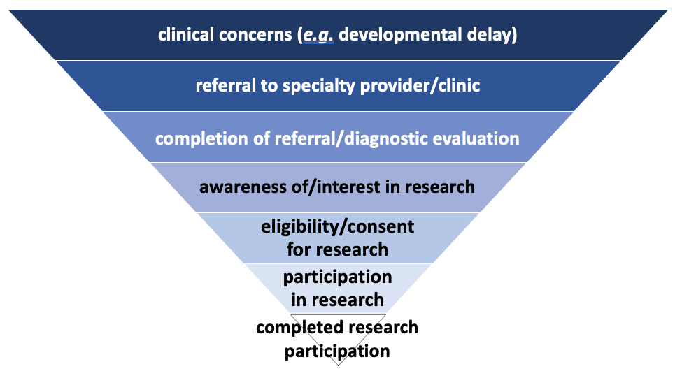

Figure 1. Points of potential exclusion in the path to research participation.

As noted by Kover and Abbeduto, traditional medical models of disability, dominant culture approaches to research recruitment, and failure to consider the importance of intersectional identities or socioenvironmental exposures, all act at each step of this process to reduce an individual’s likelihood of research participation. This is particularly true for studies of rare conditions, where disparities in access to clinical care (such as specialty providers or sophisticated diagnostic testing) are magnified for marginalized groups.
As a result, a preponderance of research “evidence” in many areas of IDD is based on data from participants who bear little resemblance to the larger communities they represent. The extent to which these research findings truly generalize to more diverse populations is entirely unknown. These systemic barriers must be addressed to maximize the rigor, reproducibility, and validity of future IDD research.
Future challenge: Making abstract DEIA efforts real for every member of the IDD research community
When surveyed in abstract terms, most biomedical researchers (almost 90% in one recent study) (Passmore et al., 2022) report seeing value in improving inclusion of individuals from underrepresented groups in research. However, researchers often have dramatically different responses when asked about the importance of DEIA efforts to their own research – in this same study, less than 40% of respondents identified DEIA as important to their own efforts. When asked to explain, many researchers described diversity as “an impractical, even unattainable, goal.”

In order to move the needle toward equity, every member of the IDD community must see DEIA as central to their own research efforts, even in the face of seemingly daunting obstacles. Only with personal ownership of DEIA values, by those who have benefited from dominant culture systems as well as those who have been excluded from them, can the community make true progress toward equity in IDD research.

Funding: none
Conflicts of interest: none

References
Advisory Committee to the Director Working Group on Diversity, Subgroup on Individuals with Disabilities. (2022). Report. https://www.acd.od.nih.gov/documents/presentations/12092022_WGD_Disabilities_Subgroup_Report.pdf. Retrieved February 9, 2023.
Bernard, M. A. (2022). New Recommendations for Enhancing Disability Inclusion. Blog: NIH Chief Officer for Scientific Workforce Diversity (COSWD). https://diversity.nih.gov/blog/2022-12-30-new-recommendations-enhancing-disability-inclusion. Posted December 30, 2022; Retrieved February 9, 2023.
Byrnes, N. (2021). CSR’s Commitment to Advancing Equity, Diversity and Inclusion in Peer Review. Open Mike Blog. https://nexus.od.nih.gov/all/2021/03/08/csrs-commitment-to-advancing-equity-diversity-and-inclusion-in-peer-review/ Posted March 8, 2021; Retrieved February 11, 2023.
Ginther, D. K., Schaffer, W. T., Schnell, J., Masimore, B., Liu, F., Haak, L. L., & Kington, R. (2011). Race, ethnicity, and NIH research awards. Science, 333(6045), 1015-1019. https://doi.org/10.1126/science.1196783
Passmore, S. R., Kisicki, A., Gilmore-Bykovskyi, A., Green-Harris, G., & Edwards, D. F. (2022). "There's not much we can do..." researcher-level barriers to the inclusion of underrepresented participants in translational research. J Clin Transl Sci, 6(1), e4. https://doi.org/10.1017/cts.2021.876

